Project Proposal Final Draft - Neal Traynor

**1. INTRODUCTION**

Our class has been assigned to design a 3-wheeled electric assist bicycle for our client, Kaia Nightingale. Each group chose a focus for their project pertaining to the bicycle. My team is responsible for the design of the body and frame of the vehicle. This includes the size, shape, and the materials of the frame and outer body. It also includes the interior and security features.

**2. BACKGROUND INFORMATION**

Kaia Nightingale is our Client who has requested that our class design a 3-wheeled electric assist bicycle for her. She wants this bike to be usable in both the summer and winter months. She also wants 2 front wheels, and one back wheel. On top of that, she wants the engine to assist when going up hills, and to help maintain a constant speed. Our group will contribute the body and frame of this bicycle. We will design the shape, size, and the materials that will be used for the interior and exterior of the bike. We will have to work very closely with the other groups to make sure that our designs will be able to fit around their designs, such as the engines, the accessories, et cetera.

**3. PROJECT DESCRIPTION**

Designing the Body and Frame of the bike requires a lot of tasks to be completed. As a result, each team member has a specific focus for their research. The research that each member will be doing is as follows;

* **(3.1) Nick Kamarianakis:** Nick will be researching on what materials will be best for making the bike. The engineering principles he will look at are durability, strength-to-weight ratio, and cost effectiveness.
* **(3.2) Douglas Raymond:** Doug will be researching on the shape and size of the bike. The engineering principles he will look at are aerodynamics, and efficiency. He will need to find the best compromise between aerodynamics and comfort.
* **(3.3) Jacob Hawley:** Jacob will be researching on the frame of the bike. The 2 engineering principles he will look at are force distribution, and center of mass. He will need to find a way to make as sturdy a frame as possible without sacrificing a light weight bicycle.
* **(3.4) Will Rose:** Will is researching on the interior of the bike. The two engineering principles he will look at are ergonomics, and adaptability. He has to find a way to make the interior of the car as appealing and user-friendly as possible.
* **(3.5) Neal Traynor:** I will be researching on the locking mechanism and security of the bicycle. Three engineering principles I will look at are Durability, simplicity, and effectiveness. I will need to find a way to make the lock as effective as possible, while keeping it as cheap and easy as possible to operate.

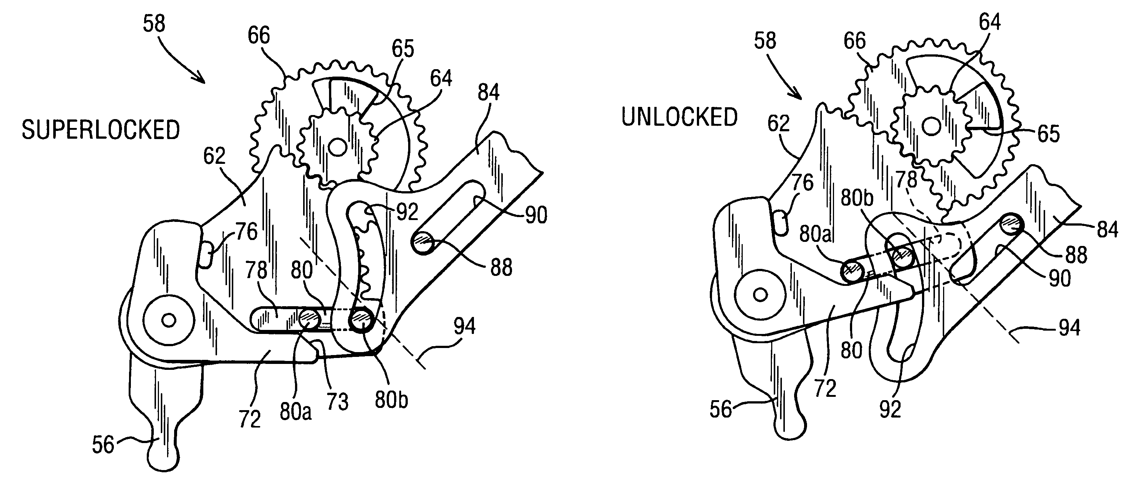

This is a drawing of a basic car lock mechanism. A similar design would be used for the security of the recumbent bicycle.

The engineering principles that my teammates will follow will greatly affect my work and the principle that I will follow. I will need to find a way to adapt a lock that will work well with the materials that Nick chooses to build the bike with. I will need to make the lock as sleek yet secure as possible so that it will not affect the aerodynamics that Douglas worked to make as good as possible. I will need to make the security system lightweight in order to not affect the weight distributions calculated by Jacob. Finally, I will need to make the system as visually appealing and user-friendly as possible to work well with William's work on the ergonomics of the vehicle.

**4. PROJECT TIMELINE**

See appendix A for details.

**5. TEAM CONTRACT**

See appendix B for details.

**6. CONCLUSION**

To summarize, I hope that this proposal will be accepted. Thank you!

**7. REFERENCES**

[1] F. Neumann, "Automobile Door Lock," U.S. Patent 5 622 396, April, 22, 1997.

[2] A. J. Roppo, "Automobile Door Lock," U.S. Patent 3 612 588, Oct, 12, 1971.

**APPENDIX A**

|  |  |
| --- | --- |
| **Date** | **Description** |
| Oct 7th 2013 | Presentation of preliminary findings |
| Oct 14th 2013 | Preliminary Report due |
| Oct 21st 2013 | Status Presentation |
| Nov 11th 2013 | Report of findings |
| Nov 18th 2013 | Presentation of findings |

**The team meets every Sunday at 2pm for 2 hours to organize ideas and deliverables to plan for following classes

**APPENDIX B**

1. Roles and Associated Responsibilities
   1. Team Leader

Group Member: Will Rose

Responsibilities:

1. Assignment Aggregation.
2. Quality Control
3. Arbitration
4. Schedule Group Meetings
   1. Team Liason

Group Member: Douglas Raymond

Responsibilities:

1. Inter-group communication
2. Facilitate inter-group meetings to coordinate related research.
   1. Team Minuteman

Group Member: Nick Kamarianakis

Responsibilities:

1. Record Keeping.
2. Record discussions and meetings
3. Participation
   1. All tem members will participate equally for team projects (assignments where there are team marks) and presentations
   2. There will be no substitution of work or responsibilities that relate to the fulfillment of assignments
   3. Where there is a conflict or uneven distribution of work, Team Leader will allocate and arbitrate as necessary.
   4. Failure to participate, for any reason, or not participate to the standard of quality equally, see Section 4.1, will result in the guilty party receiving additional work in equal quantity of unparticipated amount or removal from the group if guilty party is deemed detrimental and hazardous to group quality.
   5. All members will attend group meetings.
   6. Group meetings will be liquid. All meeting times will coordinate with group member schedules. See Section 3.1.
4. Decision-Making
   1. Group decisions will be made by unanimous consensus.
   2. No action will be taken without full team forewarning, discussion, and consensus.
   3. Where conflict exists in the decisions of an action, Team Leader will arbitrate.
5. Assignment Quality and Guidelines
   1. All minimum standards set out in course outline and term package will be met.
   2. Where there exists a group submission
      1. Individual member submissions will be collected by Team Leader to aggregated into one submission
      2. Team member submissions will be submitted to Team Leader at a reasonable date before the due date of the assignment. See Section 3.1.
      3. Member submissions will adhere to the minimum standards herein stated. See Section 4.1.
      4. Failure to submit component will result in consequences stated in Section 2.4.
   3. Research sources will be cited in IEEE format set out in the term package.